|  |
| --- |
|  |
| Capstone Project Document |

**FIRST AID**

**Report #1 – Project Introduction**

|  |  |  |
| --- | --- | --- |
| **First Aid** | | |
| **Group Members** | Đàm Huy Hùng | SE03431 |
| Nguyễn Duy Anh | 01525 |
| Mai Trung Kiên | SE02994 |
| Nguyễn Tiến Dũng | SE03272 |
| Nguyễn Phúc An | SE03118 |
| **Supervisor** | Mr. Nguyễn Văn Sang | |
| **Project code** | FAVN | |

**- Hanoi, 09/2016–**

# SIGNATURE PAGE

AUTHOR: Nguyễn Duy Anh 06/09/2016

Team member

REVIEWERS: Đàm Huy Hùng 08/09/2016

Project manager

APPROVAL: Nguyễn Văn Sang --/--/--16

Supervisor

Record of change

*A - Added M - Modified D – Deleted

|  |  |  |  |  |  |
| --- | --- | --- | --- | --- | --- |
| Effective Date | Changed Item | A,M,D | Change Description | Reason for Change | Rev. Number |
| 06/Sep/2016 | Create Introduction | A | Create Introduction | First version | 1.0 |
|  |  |  |  |  |  |
|  |  |  |  |  |  |
|  |  |  |  |  |  |
|  |  |  |  |  |  |
|  |  |  |  |  |  |

Table Contents

SIGNATURE PAGE 1

1 INTRODUCTION 4

1.1 Purpose 4

1.2 Acronyms and Definitions 4

2 ABSTRACT 4

3 LITERATURE REVIEW 4

4 PROPOSAL 8

4.1 The idea 8

4.2 Objectives 8

4.3 Brief description about system 9

4.4 System features 10

4.4.1 First aid application features 10

4.4.2 Ambulance application features. 11

4.4.3 Dispatcher application features 11

4.4.4 Admin/Expert Application 11

5 BENEFIT FROM PROJECT 12

5.1 For our group 12

5.2 For Community 12

6 CRITICAL ASSUMPTION AND CONSTRAINTS 12

7 POTENTIAL RISKS 13

8 REFERENCES 13

# INTRODUCTION

## Purpose

This document is created as the introduction for project First Aid – our Capstone Project at FPT University. In this document, we will describe the initial idea for our project, overview some existing systems, describe our expected system as well as to give some critical assumptions, constrains and potential risks. Moreover, this document also shows opportunities that it offers to users.

## Acronyms and Definitions

|  |  |
| --- | --- |
| **Acronym & Abbreviation** | **Definition** |
| FA | First Aid |
| FU | FPT University |
| Q&A | Question and Answer |
|  |  |

**Table 1-1:** Definitions and Acronyms

# ABSTRACT

In daily life, illness or injury can occur suddenly. There are many situations that require first aid to stop the situation becoming worse, even save lives and reduce injuries. The first aid does not necessarily require complicated techniques or special knowledge. However, not many people in Vietnam have sufficient knowledge and necessary skills enough for the aid. There are a lot of specific training materials in hard and soft copies, but its disadvantage is hard to comply with the right method of first aid immediately without visual information. There are also other mobile applications for first aid on the market but they have barriers for users such as language and the lack of effective interaction.

In addition, the supports emergency system of Hanoi 115 emergency center in particular and almost provinces of Vietnam in general have currently limitations. The receiving of information from the victim to call is done by pen and paper; dispatchers of the 115 center contact to the emergency team via phone or walkie-talkie. The victim's location is determinate via their description. There have many cases in which the victim describes wrong location or the driver goes in wrong way that leads to cause wasted-time and the critical status of victim’s life.

With the expectations of helping people to cope with the limitations that mentioned above, we propose to build an application that can provide users with simple instructions on first aid and a dispatch ambulance system for the Hanoi 115 emergency center.

# LITERATURE REVIEW

Nowadays, there are some first aid applications on the market. However, according our research, these applications are not really useful for Vietnamese people. In this section, we are focusing on the three top rating applications which are considered as our rivals.

* **Cẩm nang sơ cứu**

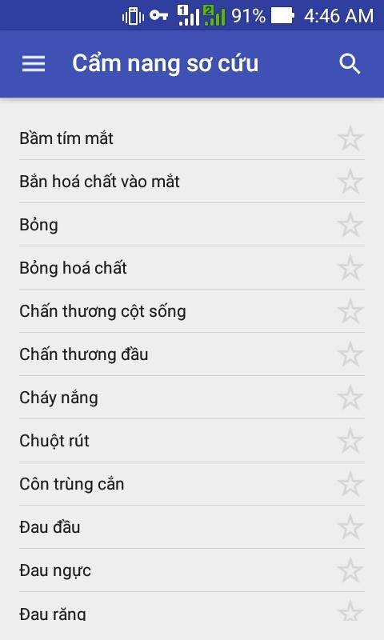

**Figure 1-1:** App Cẩm nang sơ cứu

“Cẩm nang sơ cứu”is the only topdownload application that provides knowledge about first aid instructions that developed on the Android platform for the Vietnamese.

* **Advantages:**
* Has Vietnamese language: “Cẩm nang sơ cứu” was developed by Vietnamese developers so this application has Vietnamese language, easy to use for Vietnamese users.
* A lot of first aid guide: Comparing to the vietnam’s applications, the instructions of first aid in this application covers many medical fields such as insect bites, cramps…
* The searching function: Because this application has lots of first aid guidelines, so the searching function is quite useful to help users easily to search for the appropriate guidance in case of emergency.
* **Disadvantages:**
* Lack of visualization: The structure of the application has not been arranged logically, first aid guidelines are not sorted into groups, sometimes confusing for users.
* Instructions are difficult to follow: The contents of the first aid instructions are sketchy, the illustrations as well as the guide’s step is not really useful.
* In the first aid instructions, the source of information is not really realiable.
* **Hướng dẫn sơ cứu**

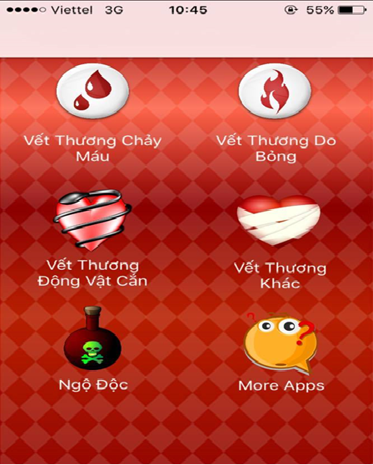

**Figure 1-2:** App Hướng dẫn sơ cứu

“Hướng dẫn sơ cứu” is the top application that provides knowledge about first aid instructions that developed on the iOS platform for the Vietnamese.

* **Advantages:**
* Has Vietnamese language: “Hướng dẫn sơ cứu” was developed by Vietnamese developers so this application has Vietnamese language, easy to use for Vietnamese users.
* First aid methods are grouped by topics: The method of first aid instructions are reassembled according to topic, quite intuitive and logical.
* **Disadvantages:**
* A few first aid guide: The first aid instructions are not many, the contents of the first aid manual as the first aid steps, the illustrations are quite sketchy or may not have.
* Without searching function: The functions are quite sketchy, morever this application does not have “ Search” function so difficult to look up to appricatioe guide.

In the first aid instructions, the source of information is not really realiable.

* **First Aid**

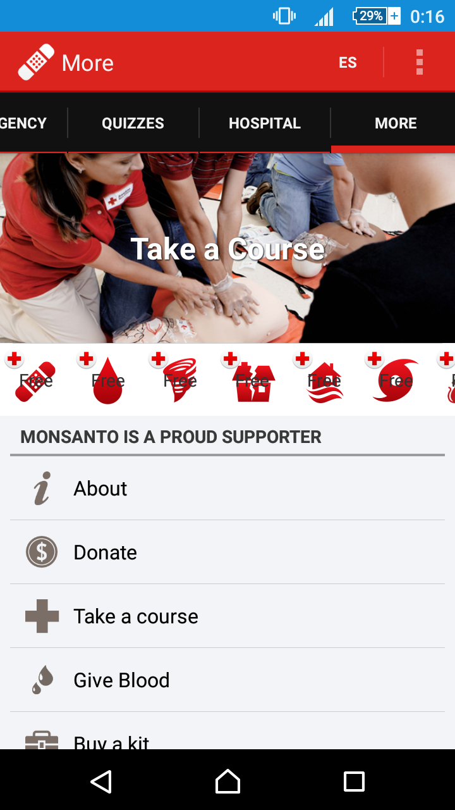

**Figure 1-3:** App First Aid

First Aid is the biggest application for first aid guide created by American Red Cross, users can look up and learn about first aid, watch videos, take quizzes.

* **Advantages:**
* Simple step-by-step instructions guide you through everyday first aid scenarios.
* Fully integrated with 9-1-1 so you can call EMS from the app at any time.
* Videos and animations make learning first aid fun and easy.
* Preloaded content means you have instant access to all safety information at any time, even without reception or an Internet connection.
* First Aid has friendly interface, clear instructions.
* **Disadvantages:**
* Just have English and Spanish language.
* It is not popular in Vietnam.
* Without searching function.

# PROPOSAL

## The idea

With the aim of providing the best supported health service for Vietnamese people, we want to develop an application that allows users can look up and perform first aid guide and selectively synthesized under step by step format in the easiest way. This application also supports users to search medical facilities around their location. Besides we also want to develop an emergency switchboard system for Hanoi 115 emergency center. It means that this system can connect to aid applications through SOS calling with reducing talking time as well as providing maximum necessary information. In addition, the system also has admin/expert application for managing, automatic functions connected to software on an ambulance in order to shorten the time to contact and distance traveled; functional navigation map and directions to emergency help achieve maximum efficiency.

## Objectives

This project is the Capstone Project in FPT University studying program.

The project is responsible for all team members. So, we have to complete all requests from teachers and the university. In terms of IT expertise, by implementing of the project, we expect to be able to learn how to develop a project, how to manage the project, how to communicate better among members in groups, how to control the time, how to implement effective teamwork. Moreover, besides the knowledge of IT learnt from school, we want to study deeply new technologies, new techniques for serving the process of implementation of the project. Therefore, we believe that this project is a great opportunity for us to enhance the skills and knowledge. This also makes our CV better after graduation from FPT University. This is also an opportunity for us to demonstrate our competence with employers.

In term of social-meaning, with First Aid projects, we will support the best health service for people that need the help in aid issues. Via this application users can have better understanding about aid and the importance of first aid. Beyond that, the community will have good software that can help them protect their lives and health more safely. Also, for Hanoi 115 Emergency Center, we want to build for them an automatic ambulance coordination system to resolve their current problems, to improve the quality of medical management.

## Brief description about system

The First Aid system includes “First Aid” mobile application and “Ambulance” application developed on the Android platform, an emergency switchboard system for Hanoi 115 center and data management system developed on the web platform. The most useful feature of this application is to help users easily perform first aid through step-by-step instructions. It also provides a number of features needed for emergencies such as finding the nearest medical facility, making phone calls and sending information to the dispatch system of 115 center. It will provide the nearest ambulance to the patient automatically. The Ambulance applications can get quick tasks from the switchboard, identify the exact location of the victim on the road map and the closest to the victim. Last but not least, the data management system will give the functions of data management as well as user management, this system is called “Admin/Expert”.

The technology used to develop the First Aid: Java, Android, Bootstrap, and Laravel - PHP framework.

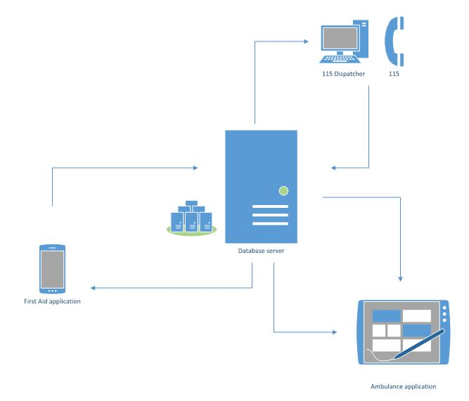

**Figure 1-4:** Brief descriptions diagram of First Aid

## System features

In our system, First Aid mobile app is the most prominent application that provides you the first aid methods in concise step-by-step, easy to understand, easy to implement. It has special features such as determining your locate on a map to and supporting medical facilities within a specific radius, direct hotline to call, the location of health facilities and guide the way to there. You can also ask questions about health issues and get answers from experts. Besides the above functions, we also support interactive functions with the 115 emergency center to shorten the duration of your emergency call.

When using our app to call 115, your personal information (including phone number and your location) will be sent to the dispatch system of the 115 center (also developed by us) is called “Dispatcher”. There are two ways to call 115 from this app. You can call 115 from the main screen of this app as well as from the instruction steps screen which is located in the list of injuries. Specially, if you call from the instruction steps screen, your symptom will also be sent to the switchboard, the dispatcher can rely on this information to give the right emergency advice to your case. From that information, the dispatcher can conduct an ambulance to pick you up by car automatic functions of our system. The ambulance pick you up will be the car that is nearest to your location.

The ambulance will also have a software is called “Ambulance” application can show your location and directs to it through the electric map. It helps to reduce the wrong direction cases. The ambulance status is also constantly updated, the dispatcher can fully know the location of it and its ready status or not in order to manage the most effectively.

In addition, the features of the user comments are used to communicate with the administrator. Data management features allow administrators to manipulate and manage data such as database of First Aid applications, opinions of users. User management features allow administrators to manage the account dispatcher, ambulance staff and medical experts.

### First Aid Application features

* **List of injuries:** List of common injuries will be displayed in main screen when users launch in First Aid application
* **Instruction steps of injury:** Instructions steps first aid of an injury will be shown when users tap on an injury’s name.
* **Searching:** Users search the related keywords of injury and results will be displayed in the screen.
* **Reading steps of instructions:** Read steps of instructions for users. Users can perform first aid and listen to steps of instructions at the same time.
* **Call 115:** This feature will help users to call 115. In an emergency that need to call 115, this feature can send to operator the user information including phone numbers and coordinates.
* **Current location:** Users can get their exact location via the map. In case there is no exact address, the users can get the nearest locations.
* **Finding nearby health facilities:** Users can find list of the nearest health facilities and see address, distance, phone number, and directions to the health facilities.
* **Learning:** Information about instructions of each injury will be explained more clearly than the instruction steps first aid in emergency screen. This feature will help users to have more knowledge about first aid in injury situations.
* **FAQs:** Users can see FAQs about an injury and send questions about injuries
* **More:** This feature is a collection of some other popular features for users :
  + Send feedback.
  + View first aid course.
  + Sharing.

### Ambulance Application features

* **Login/Logout:** Ambulance staff need to login to use the account. The staff account can be given by administrators.
* **Notify task:** Ambulance staff can receive the task automatically from the coordinator without making a phone call or using walkie-talkie like traditional way.
* **Location of caller:** Ambulance staff will determine the caller’s location exactly and know the shortest way from the location of ambulance to the location of caller.
* **Report to Dispatcher:** Ambulance can report to dispatcher after picking up victim to hospital.
* **Status:** Ambulance will report to dispatcher about the ambulance status of implementing task or not.

### Dispatcher Application features

* **Login/Logout:** Dispatcher need to login to use the account. Dispatcher’s account is given by administrator.
* **Dispatch ambulance:** Dispatcher receives information from users including their status and their coordinates, then dispatcher will dispatch the ambulance to the victim’s location. The system will automatically choose the nearest available ambulance.
* **Show direction from ambulance to caller:** dispatcher will know the nearest way from ambulance’s location to victim’s location and follow ambulance’s moving.
* **View ambulance information:** Dispatcher can know about the available of ambulance .
* **Cancel emergency case:** In case the victim doesn’t need ambulance, dispatcher can cancel task.

### Admin/Expert Application features

* **User management:** Admin can create new account for dispatcher, ambulance staff and health expert, update, delete and search account.
* **Data Management:** Medical expert can delete, update, or add new information about first aid.
* **Users’ questions management:** Admin and expert will receive notifications when there are comments or questions from users and answer them.

# BENEFIT FROM PROJECT

## For our group

After developing and implementing this project, our group will get some benefits:

* Have more experiences of software project management how to manage plan, time, member and risk.
* Have more knowledge and skills about HTML/ CSS , Android and PHP programming.
* Know how to communicate with team members and how to make teamwork more effective.
* If this application is approved, we will get a good mark in Capstone Project. It makes our grade better.

## For Community

With only mobile device, users can easily search and follow the instructions of first aid in case of emergency. If it is done properly and timely, victims can minimize the damage and recover faster recover. In particular, in many cases, this can save lives.

If First Aid mobile application is widespread, we hope to contribute to raise the awareness of Vietnamese people of the importance of understanding of basic aid skills. It is the way to protect people’s health and life.

Besides, by proposing the construction of a coordination system and mobile applications on the central ambulance for 115, we believe that if the FA applications is applied for real, the system will solve a lot of these shortcomings and limitations to the 115 emergency center.

# CRITICAL ASSUMPTION AND CONSTRAINTS

* Critical assumption:
  + For the Technical training: we assumed web developers can study about PHP and mobile developers can train about application development for Android platform in one week. Besides, testers also have enough knowledge about software testing process.
  + For the human resources: we assumed all members have a good healthy to do their task sand meet the project plan's deadline.
* Constraints:
  + Time and deadline: we have to work 5 hours/day and 5 days/week to submit weekly report on time for the supervisor and finish entire project in 14 weeks.
  + Quality: We need to ensure that our product could be run well on android mobile devices with android OS version 4.4 or higher.
  + Process: We have to follow the software processing of FPT Software
  + Human resources: There are 5 member in our team, each member have to study 2 subjects (Japanese and JIT) at school.

# POTENTIAL RISKS

After studying about this project, we find out some problem that we may be encountered:

* Under-estimate scope and time or miss deadline because lack of experience in group working, managing and controlling work.
* Loss data, source code before uploading data to server because of careless.
* Equipment got broken because of careless or accident.
* Human resources: Team member cannot complete their works because of health reasons, key member leave team or un-cooperating on team.
* Change requirements: Requirement changed when some functions cannot be completed or some technologies is not suitable.

# REFERENCES

* **Cẩm nang sơ cứu at URL:** <https://play.google.com/store/apps/details?id=com.ss.stp.camnangsocuu>
* **Hướng dẫn sơ cứu at URL:**

<https://itunes.apple.com/vn/app/huong-dan-so-cuu/id588610279?mt=8>

* **First Aid at URL:**   
  https://itunes.apple.com/us/app/first-aid-by-american-red/id529160691?mt=8